Eclipse Workspace – Automate GUI Elements Form Using Selenium
Prepared By: Ayan Mal
Used url: https://testautomationpractice.blogspot.com/
Framework: Selenium + Java + TestNG + Maven + Page Object Model (POM)
Project Type: Web Page Automation Testing
Github link---- https://github.com/ayan-mal/Capstone-Project

Project Structure :
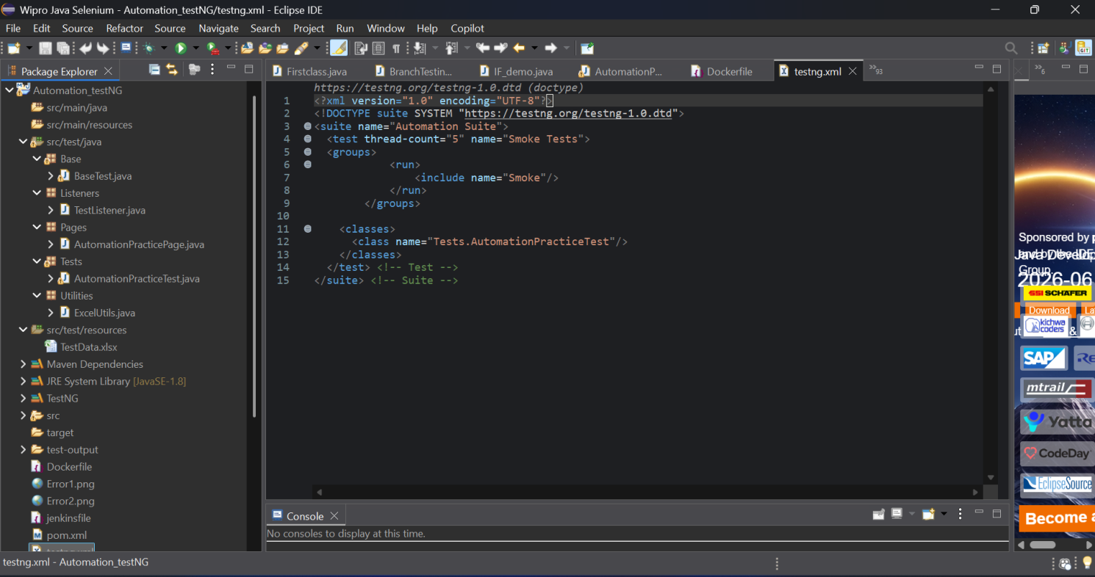
BaseTest.java

package Base;

import java.time.Duration;

import org.openqa.selenium.JavascriptExecutor;
import org.openqa.selenium.WebDriver;
import org.openqa.selenium.chrome.ChromeDriver;
import org.openqa.selenium.chrome.ChromeOptions;
import org.openqa.selenium.edge.EdgeDriver;
import org.openqa.selenium.support.ui.WebDriverWait;
import org.testng.annotations.AfterTest;
import org.testng.annotations.BeforeTest;

public class BaseTest {

protected WebDriver driver;
protected WebDriverWait wait;
protected JavascriptExecutor js;

@BeforeTest(alwaysRun = true)
public void setup() {

/*ChromeOptions options = new ChromeOptions();

options.addArguments("--headless=new");
options.addArguments("--no-sandbox");
options.addArguments("--disable-dev-shm-usage");
options.addArguments("--window-size=1920,1080");

driver = new ChromeDriver(options);*/

driver = new EdgeDriver();
// driver.manage().window().maximize();
driver.get("https://testautomationpractice.blogspot.com/");
wait = new WebDriverWait(driver, Duration.ofSeconds(5));
js = (JavascriptExecutor) driver;
System.out.println("Browser opened");
}

@AfterTest(alwaysRun = true)
public void tearDown() {

if(driver != null) {
driver.quit();
}

System.out.println("All tabs closed");
}
}

TestListener.java
package Listeners;

import org.testng.ITestContext;
import org.testng.ITestListener;
import org.testng.ITestResult;

public class TestListener implements ITestListener {

@Override
public void onTestStart(ITestResult result) {
System.out.println("STARTED : " + result.getName());
}

@Override
public void onTestSuccess(ITestResult result) {
System.out.println("PASSED : " + result.getName());
}

@Override
public void onTestFailure(ITestResult result) {
System.out.println("FAILED : " + result.getName());
}

@Override
public void onTestSkipped(ITestResult result) {
System.out.println("SKIPPED : " + result.getName());
}

@Override
public void onStart(ITestContext context) {
System.out.println("Test Execution Started");
}

@Override
public void onFinish(ITestContext context) {
System.out.println("Test Execution Completed");
}
}

AutomationPracticePage.java
package Pages;

import java.io.File;
import java.io.IOException;
import java.util.Set;

import org.openqa.selenium.Alert;
import org.openqa.selenium.By;
import org.openqa.selenium.JavascriptExecutor;
import org.openqa.selenium.Keys;
import org.openqa.selenium.OutputType;
import org.openqa.selenium.SearchContext;
import org.openqa.selenium.TakesScreenshot;
import org.openqa.selenium.WebDriver;
import org.openqa.selenium.WebElement;
import org.openqa.selenium.interactions.Actions;
import org.openqa.selenium.io.FileHandler;
import org.openqa.selenium.support.ui.Select;
import org.openqa.selenium.support.ui.WebDriverWait;
import org.testng.Assert;

public class AutomationPracticePage {
WebDriver driver;
WebDriverWait wait;
JavascriptExecutor js;
//Select_field
By Name=By.id("name");
By Email=By.id("email");
By Phone=By.id("phone");
By Address=By.id("textarea");
By Male=By.id("male");
By Female=By.id("female");
By Day1=By.id("sunday");
By Day2=By.id("tuesday");
By Country=By.id("country");
By Colors=By.id("colors");
By Animals=By.id("animals");
//Date_picker
By Date_picker1=By.id("datepicker");
By Date1=By.xpath("//*[@id=\"ui-datepicker-div\"]/table/tbody/tr[3]/td[4]/a");
By Date_picker2=By.id("txtDate");
By Date2=By.xpath("//*[@id=\"ui-datepicker-div\"]/table/tbody/tr[4]/td[7]/a");
By Start_date=By.id("start-date");
By End_date=By.id("end-date");
By Submit_button=By.xpath("//*[@id=\"post-body-1307673142697428135\"]/div[8]/button");
//Upload_files
By Single_input=By.id("singleFileInput");
By Multiple_input=By.id("multipleFilesInput");
//alerts
By Alrt_btn=By.id("alertBtn");
By conf_btn=By.id("confirmBtn");
By prmpt_btn=By.id("promptBtn");
//Tabs
By Tabs=By.id("Wikipedia1_wikipedia-search-input");
//Actions
By Dyn_click=By.xpath("//*[@id=\"HTML5\"]/div[1]/button");
By Dub_click=By.xpath("//*[@id=\"HTML10\"]/div[1]/button");
By Drag=By.id("draggable");
By Drop=By.id("droppable");
By Mouse=By.xpath("//*[@id=\"HTML3\"]/div[1]/div/button");
By Slider=By.xpath("(//span[@class=\"ui-slider-handle ui-corner-all ui-state-default\"])[1]");
By Combobox=By.id("comboBox");
By Scroll=By.xpath("//*[@id=\"dropdown\"]/div[4]");
//Forms
By Sel1=By.xpath("//*[@id=\"productTable\"]/tbody/tr[2]/td[4]/input");
By Sel2=By.xpath("//*[@id=\"productTable\"]/tbody/tr[1]/td[4]/input");
By Input1=By.id("input1");
By Btn1=By.id("btn1");
By Input2=By.id("input2");
By Btn2=By.id("btn2");
By Input3=By.id("input3");
By Btn3=By.id("btn3");
By Shadow_host=By.id("shadow_host");
By Text=By.cssSelector("input[type='text']");
By Box=By.cssSelector("input[type='checkbox']");
By File=By.cssSelector("input[type='file']");
//Pop-up & New tab
By New_tab=By.xpath("//button[normalize-space()='New Tab']");
By Pop_up=By.xpath("//*[@id=\"PopUp\"]");
//Links
By Link1=By.linkText("Lenovo");
By Error1=By.linkText("Errorcode 404");
By Error2=By.linkText("Errorcode 500");

public AutomationPracticePage(WebDriver driver)
{
this.driver=driver;
}
public void Select_field(String nameData, String emailData,
String phoneData, String addressData,
String gender) {

driver.findElement(Name).sendKeys(nameData);
driver.findElement(Email).sendKeys(emailData);
driver.findElement(Phone).sendKeys(phoneData);
driver.findElement(Address).sendKeys(addressData);

if(gender.equalsIgnoreCase("Male")) {
driver.findElement(Male).click();
}
else {
driver.findElement(Female).click();
}

driver.findElement(Day1).click();
driver.findElement(Day2).click();

WebElement coun=driver.findElement(Country);
coun.click();
coun.sendKeys("Canada");
coun.sendKeys(Keys.ENTER);
WebElement col=driver.findElement(Colors);
Select col1=new Select(col);
col1.selectByValue("red");
WebElement sort=driver.findElement(Animals);
Select sort1=new Select(sort);
sort1.selectByValue("cheetah");
}

public void Date_picker() {
driver.findElement(Date_picker1).click();
driver.findElement(Date1).click();
driver.findElement(Date_picker2).click();
driver.findElement(Date2).click();
driver.findElement(Start_date).sendKeys("05-06-2026");
driver.findElement(End_date).sendKeys("17-06-2026");
driver.findElement(Submit_button).click();
}
public void Upload_files() {
WebElement upload=driver.findElement(Single_input);
upload.sendKeys("C:\\Users\\HP\\Downloads\\Ayan.png");
WebElement upload1=driver.findElement(Multiple_input);
upload1.sendKeys("C:\\Users\\HP\\Downloads\\Ayan.png");
upload1.sendKeys("C:\\Users\\HP\\Downloads\\Ayan Mal Photo 3.jpeg");
}
public void alerts() {
//Simple alert
driver.findElement(Alrt_btn).click();
driver.switchTo().alert().accept();
//confirmation alert
driver.findElement(conf_btn).click();
driver.switchTo().alert().dismiss();
//prompt Alert
driver.findElement(prmpt_btn).click();
Alert alert= driver.switchTo().alert();
alert.sendKeys("Welcome to java");
alert.accept();
}
public void Tabs() {
WebElement tab=driver.findElement(Tabs);
tab.click();
tab.sendKeys("Hii");
tab.sendKeys(Keys.ENTER);
}
public void Actions() {
//dynamic click
WebElement dcc=driver.findElement(Dyn_click);
Actions ac1=new Actions(driver);
ac1.moveToElement(dcc).click().perform();
//Double click
WebElement dc=driver.findElement(Dub_click);
Actions ac2=new Actions(driver);
ac2.doubleClick(dc).perform();
//Drag and Drop
WebElement sr=driver.findElement(Drag);
WebElement tg=driver.findElement(Drop);
Actions ac=new Actions(driver);
ac.dragAndDrop(sr, tg).perform();
//Mouse hover
WebElement moc=driver.findElement(Mouse);
ac.moveToElement(moc).perform();
//slider
WebElement sr1=driver.findElement(Slider);
Actions ac3=new Actions(driver);
ac3.dragAndDropBy(sr1, 50, 0).perform();// move right
//Scrolling drop down
driver.findElement(Combobox).click();
WebElement sdd=driver.findElement(Scroll);
sdd.click();
}
public void Form() {
//Pagination
driver.findElement(Sel1).click();
driver.findElement(Sel2).click();
//Form
WebElement sec1=driver.findElement(Input1);
sec1.sendKeys("Nice to");
driver.findElement(Btn1).click();
WebElement sec2=driver.findElement(Input2);
sec2.sendKeys("Meet");
driver.findElement(Btn2).click();
WebElement sec3=driver.findElement(Input3);
sec3.sendKeys("You");
driver.findElement(Btn3).click();
//Shadowdom
WebElement shadowHost = driver.findElement(Shadow_host);
SearchContext shadowRoot = shadowHost.getShadowRoot();
shadowRoot.findElement(Text).sendKeys("Everything will be ok");
shadowRoot.findElement(Box).click();
shadowRoot.findElement(File).sendKeys("C:\\Users\\HP\\Downloads\\Ayan.png");
}
public void Pop_up() throws InterruptedException {
// New Tab
String mainWindowHandle=driver.getWindowHandle();
WebElement newTabBtn=driver.findElement(New_tab);
newTabBtn.click();
Thread.sleep(2000);

Set<String> allHandles = driver.getWindowHandles();
for (String handle : allHandles) {
if (!handle.equals(mainWindowHandle)) {
driver.switchTo().window(handle);
System.out.println("Switched to New Tab URL: " + driver.getCurrentUrl());
driver.close();
Thread.sleep(2000);
System.out.println("New tab closed");
break;
}
}
driver.switchTo().window(mainWindowHandle);
Thread.sleep(2000);
//Popup Window

WebElement popupBtn=driver.findElement(Pop_up);
popupBtn.click();
Thread.sleep(2000);

allHandles = driver.getWindowHandles();
for (String handle : allHandles) {
if (!handle.equals(mainWindowHandle)) {
driver.switchTo().window(handle);
System.out.println(" Switch to Popup Window URL: " + driver.getCurrentUrl());
driver.manage().window().maximize();
Thread.sleep(2000);
driver.close();
break;
}
}
driver.switchTo().window(mainWindowHandle);
}
public void Links() throws InterruptedException, IOException {
//Validate the Lenovo link using assert
WebElement brklink = driver.findElement(Link1);
brklink.click();

String actualUrl = driver.getCurrentUrl();
String expectedUrl = "https://www.lenovo.com/in/en/";

Assert.assertEquals(actualUrl, expectedUrl,
"URL validation failed!");

System.out.println("URL validation passed");

// Go back to previous page
driver.navigate().back();
Thread.sleep(2000);

//Broken Links
WebElement brklink1=driver.findElement(Error1);
brklink1.click();
Thread.sleep(2000);
TakesScreenshot err1=(TakesScreenshot)driver;
File sc=err1.getScreenshotAs(OutputType.FILE);
File dest=new File("Error1.png");
FileHandler.copy(sc, dest);
Thread.sleep(2000);

// Go back to previous page
driver.navigate().back();
Thread.sleep(2000);

WebElement brklink2=driver.findElement(Error2);
brklink2.click();
Thread.sleep(2000);
TakesScreenshot err2=(TakesScreenshot)driver;
File sc1=err2.getScreenshotAs(OutputType.FILE);
File dest1=new File("Error2.png");
FileHandler.copy(sc1, dest1);
Thread.sleep(2000);

// Go back to previous page
driver.navigate().back();
Thread.sleep(2000);
}

}

AutomationPracticeTest.java

package Tests;

import org.testng.annotations.Test;

import Pages.AutomationPracticePage;
import Utilities.ExcelUtils;

import org.testng.annotations.BeforeTest;
import org.testng.annotations.DataProvider;

import java.io.File;
import java.io.IOException;
import java.time.Duration;
import java.util.Set;

import org.openqa.selenium.Alert;
import org.openqa.selenium.By;
import org.openqa.selenium.JavascriptExecutor;
import org.openqa.selenium.Keys;
import org.openqa.selenium.OutputType;
import org.openqa.selenium.SearchContext;
import org.openqa.selenium.TakesScreenshot;
import org.openqa.selenium.WebDriver;
import org.openqa.selenium.WebElement;
import org.openqa.selenium.edge.EdgeDriver;
import org.openqa.selenium.interactions.Actions;
import org.openqa.selenium.io.FileHandler;
import org.openqa.selenium.support.ui.Select;
import org.openqa.selenium.support.ui.WebDriverWait;
import org.testng.Assert;
import org.testng.annotations.AfterTest;
import Base.BaseTest;
import org.testng.annotations.Listeners;
import Listeners.TestListener;
@Listeners(TestListener.class)
public class AutomationPracticeTest extends BaseTest {

AutomationPracticePage page;

@DataProvider(name = "userData")
public Object[][] getData() {
return ExcelUtils.getExcelData();
}
@Test(priority = 1, dataProvider = "userData",groups = {"Smoke"})
public void Select_field(String nameData,String emailData,String phoneData,String addressData,String gender) {

driver.navigate().refresh();

page = new AutomationPracticePage(driver);
page.Select_field(nameData, emailData, phoneData, addressData, gender);

System.out.println("All fields entered successfully");

}
@Test(priority = 2,groups = {"Smoke"})
public void Date_picker() {

page = new AutomationPracticePage(driver);
page.Date_picker();
System.out.println("Dates are filled successfully");

}
@Test(priority = 3,groups = {"Smoke"})
public void Upload_files() {

page = new AutomationPracticePage(driver);
page.Upload_files();
System.out.println("File uploaded successfully");

}
@Test(priority = 4,groups = {"Smoke"})
public void alerts() {
page = new AutomationPracticePage(driver);
page.alerts();
System.out.println("All alerts handled successfully");
}
@Test(priority = 5,groups = {"Smoke"})
public void Tabs(){
page = new AutomationPracticePage(driver);
page.Tabs();
System.out.println("Tab is working properly");
}
@Test(priority = 6,groups = {"Smoke"})
public void Actions() {
page = new AutomationPracticePage(driver);
page.Actions();

System.out.println("All actions performed successfully");

}
@Test(priority = 7,groups = {"Smoke"})
public void Form() {
page = new AutomationPracticePage(driver);
page.Form();

System.out.println("Shadow DOM & Form automation completed");

}
@Test(priority = 8,groups = {"Smoke"})
public void Pop_up() throws InterruptedException {
page = new AutomationPracticePage(driver);
page.Pop_up();
System.out.println("Popup Window handled successfully");

}
@Test(priority = 9,groups = {"Smoke"})
public void Links() throws InterruptedException, IOException {
page = new AutomationPracticePage(driver);
page.Links();
System.out.println("Errors are handled Successfully");

}

}

ExcelUtils.java

package Utilities;

import java.io.FileInputStream;

import org.apache.poi.ss.usermodel.DataFormatter;
import org.apache.poi.ss.usermodel.Sheet;
import org.apache.poi.ss.usermodel.Workbook;
import org.apache.poi.xssf.usermodel.XSSFWorkbook;

public class ExcelUtils {

public static Object[][] getExcelData() {

Object[][] data = null;

try {

String path = System.getProperty("user.dir")
+ "\\src\\test\\resources\\TestData.xlsx";

System.out.println("Excel Path: " + path);

// Try-with-resources automatically closes fis and workbook
try (FileInputStream fis = new FileInputStream(path);
Workbook wb = new XSSFWorkbook(fis)) {

Sheet sheet = wb.getSheetAt(0);

if (sheet == null) {
throw new RuntimeException("Sheet not found");
}

int rows = sheet.getLastRowNum();
int cols = sheet.getRow(0).getLastCellNum();

data = new Object[rows][cols];

DataFormatter formatter = new DataFormatter();

for (int i = 1; i <= rows; i++) {

for (int j = 0; j < cols; j++) {

data[i - 1][j] =
formatter.formatCellValue(
sheet.getRow(i).getCell(j));
}
}
}

} catch (Exception e) {

System.out.println("Error reading Excel file:");
e.printStackTrace();
}

return data;
}
}

TestData.xlsx
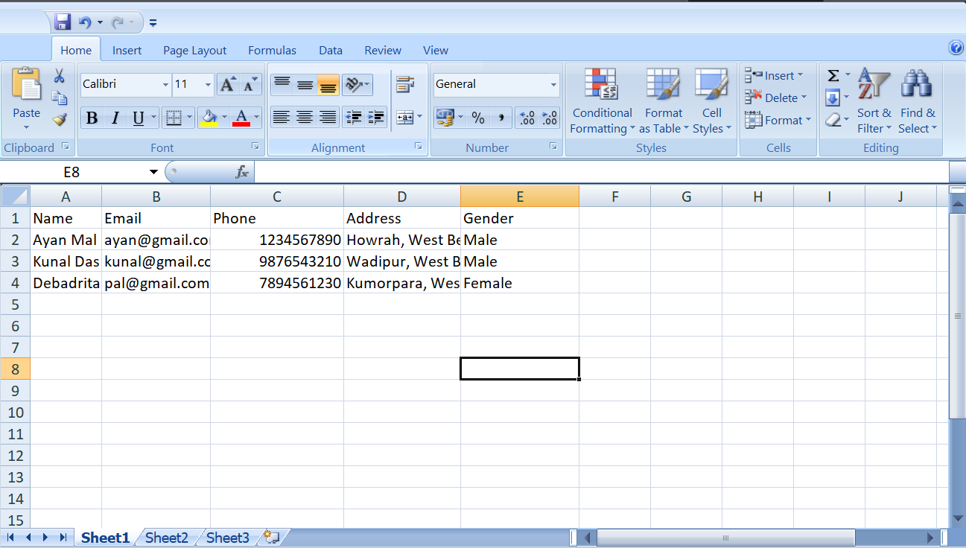

Jenkinsfile
pipeline {
agent any

tools {
maven 'Maven3'
jdk 'jdk21'
}

stages {
stage('Checkout') {
steps {
git branch: 'main',
url: 'https://github.com/ayan-mal/Capstone-Project.git'
}
}

stage('Build') {
steps {
dir('Automation_testNG') {
bat 'mvn clean'
}
}
}

stage('Compile') {
steps {
dir('Automation_testNG') {
bat 'mvn compile'
}
}
}

stage('Test') {
steps {
dir('Automation_testNG') {
bat 'mvn test'
}
}
}

stage('Package') {
steps {
dir('Automation_testNG') {
bat 'mvn package'
}
}
}
stage('Docker Build') {
steps {
dir('Automation_testNG') {
bat 'docker build -t testng-framework .'
}
}
}

stage('Docker Run') {
steps {
dir('Automation_testNG') {
bat 'docker run --rm testng-framework'
}
}
}

}

post {
always {
junit '*/target/surefire-reports/*.xml'
}
success {
echo 'Build Successful'
}
failure {
echo 'Build Failed'
}
}
}

Dockerfile
FROM maven:3.9.15-eclipse-temurin-21

WORKDIR /app

# Install Google Chrome
RUN apt-get update && apt-get install -y \
wget \
gnupg \
unzip \
&& wget -q -O - https://dl.google.com/linux/linux_signing_key.pub | gpg --dearmor -o /usr/share/keyrings/google.gpg \
&& echo "deb [arch=amd64 signed-by=/usr/share/keyrings/google.gpg] http://dl.google.com/linux/chrome/deb/ stable main" > /etc/apt/sources.list.d/google.list \
&& apt-get update \
&& apt-get install -y google-chrome-stable \
&& apt-get clean

COPY . .

RUN mvn clean install -DskipTests

CMD ["mvn","-Dtest=Tests.AutomationPracticeTest","test"]

Error1 screenshot:
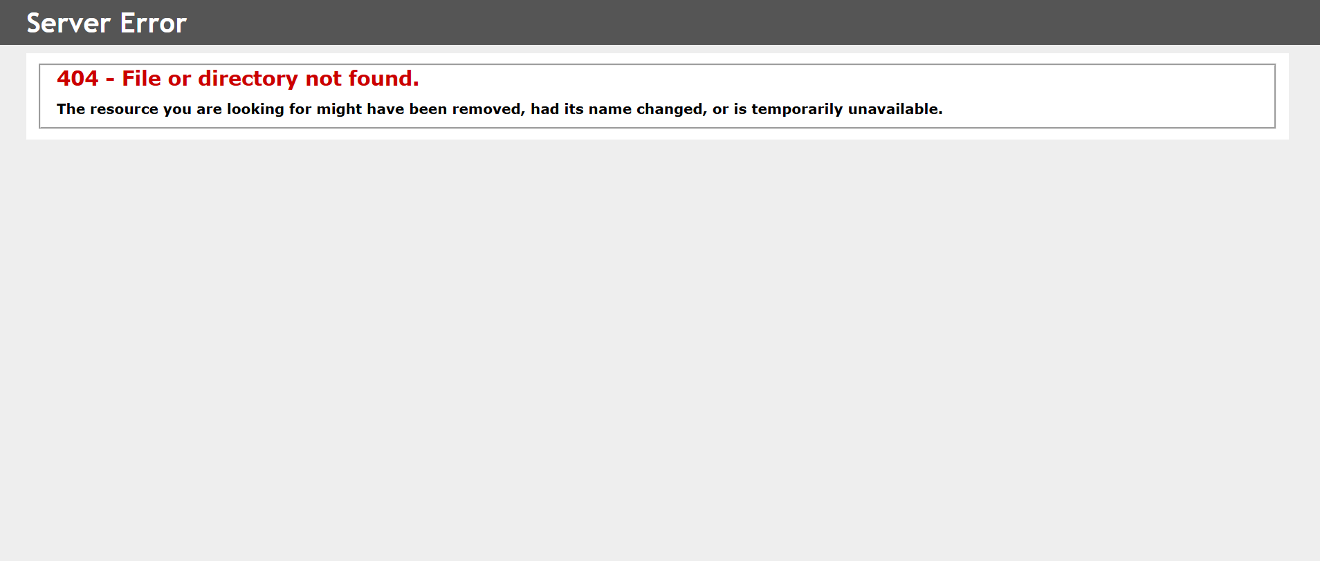

Error2 screenshot
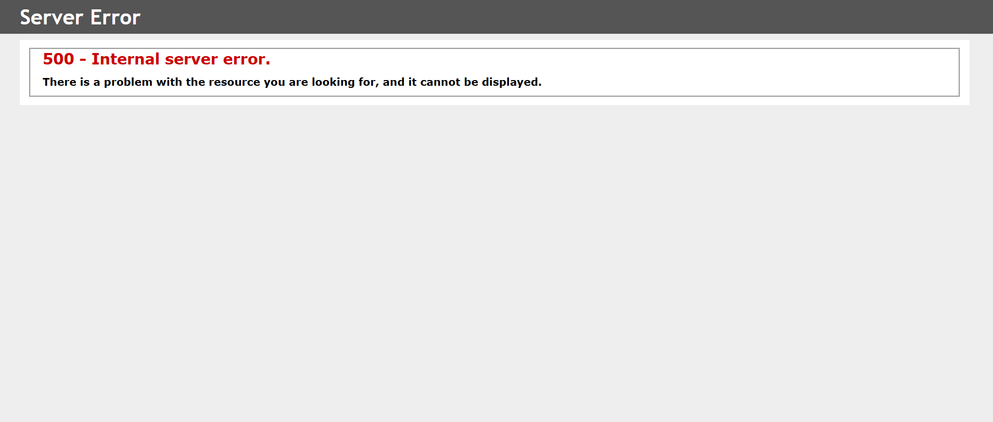

Testing.xml
<?xml version="1.0" encoding="UTF-8"?>
<!DOCTYPE suite SYSTEM "https://testng.org/testng-1.0.dtd">
<suite name="Automation Suite">
<test thread-count="5" name="Smoke Tests">
<groups>
<run>
<include name="Smoke"/>
</run>
</groups>

<classes>
<class name="Tests.AutomationPracticeTest"/>
</classes>
</test> <!-- Test -->
</suite> <!-- Suite -->

Pom.xml
<project xmlns="http://maven.apache.org/POM/4.0.0" xmlns:xsi="http://www.w3.org/2001/XMLSchema-instance" xsi:schemaLocation="http://maven.apache.org/POM/4.0.0 https://maven.apache.org/xsd/maven-4.0.0.xsd">
<modelVersion>4.0.0</modelVersion>
<groupId>Automation_testNG</groupId>
<artifactId>Automation_testNG</artifactId>
<version>0.0.1-SNAPSHOT</version>
<dependencies>
<!-- Source: https://mvnrepository.com/artifact/org.testng/testng -->
<dependency>
<groupId>org.testng</groupId>
<artifactId>testng</artifactId>
<version>7.12.0</version>
<scope>test</scope>
</dependency>
<!-- Source: https://mvnrepository.com/artifact/org.seleniumhq.selenium/selenium-java -->
<dependency>
<groupId>org.seleniumhq.selenium</groupId>
<artifactId>selenium-java</artifactId>
<version>4.44.0</version>
<scope>compile</scope>
</dependency>
<dependency>
<groupId>org.apache.poi</groupId>
<artifactId>poi-ooxml</artifactId>
<version>5.2.5</version>
</dependency>
<dependency>
<groupId>org.apache.logging.log4j</groupId>
<artifactId>log4j-api</artifactId>
<version>2.24.3</version>
</dependency>

<dependency>
<groupId>org.apache.logging.log4j</groupId>
<artifactId>log4j-core</artifactId>
<version>2.24.3</version>
</dependency>
</dependencies>
<build>
<plugins>

<plugin>
<groupId>org.apache.maven.plugins</groupId>
<artifactId>maven-surefire-plugin</artifactId>
<version>3.5.3</version>

<configuration>
<suiteXmlFiles>
<suiteXmlFile>testng.xml</suiteXmlFile>
</suiteXmlFiles>
</configuration>

</plugin>

</plugins>
</build>
</project>

Console Output:
[RemoteTestNG] detected TestNG version 7.11.0
SLF4J(W): No SLF4J providers were found.
SLF4J(W): Defaulting to no-operation (NOP) logger implementation
SLF4J(W): See https://www.slf4j.org/codes.html#noProviders for further details.
Test Execution Started
Jun 11, 2026 10:31:09 AM org.openqa.selenium.devtools.CdpVersionFinder findNearestMatch
WARNING: Unable to find an exact match for CDP version 149, returning the closest version; found: 148; Please update to a Selenium version that supports CDP version 149
Browser opened
Excel Path: C:\Users\HP\git\Capstone-Project\Automation_testNG\src\test\resources\TestData.xlsx
STARTED : Select_field
All fields entered successfully
PASSED : Select_field
STARTED : Select_field
All fields entered successfully
PASSED : Select_field
STARTED : Select_field
All fields entered successfully
PASSED : Select_field
STARTED : Date_picker
Dates are filled successfully
PASSED : Date_picker
STARTED : Upload_files
File uploaded successfully
PASSED : Upload_files
STARTED : alerts
All alerts handled successfully
PASSED : alerts
STARTED : Tabs
Tab is working properly
PASSED : Tabs
STARTED : Actions
All actions performed successfully
PASSED : Actions
STARTED : Form
Shadow DOM & Form automation completed
PASSED : Form
STARTED : Pop_up
Switched to New Tab URL: https://www.pavantestingtools.com/
New tab closed
Switch to Popup Window URL: https://www.selenium.dev/
Popup Window handled successfully
PASSED : Pop_up
STARTED : Links
URL validation passed
Errors are handled Successfully
PASSED : Links
All tabs closed
Test Execution Completed

===============================================
Automation Suite
Total tests run: 11, Passes: 11, Failures: 0, Skips: 0
===============================================

Test Report:

Smoke Tests
Tests passed/Failed/Skipped: | 11/0/0
Started on: | Thu Jun 11 13:38:22 IST 2026
Total time: | 69 seconds (69516 ms)
Included groups: | Smoke
Excluded groups:
(Hover the method name to see the test class name)

PASSED TESTS
Test method | Attribute(s) | Exception | Time (seconds) | Instance
Date_picker  Test class: Tests.AutomationPracticeTest |  | 0 | Tests.AutomationPracticeTest@179ece50
Select_field  Test class: Tests.AutomationPracticeTest  Parameters: Kunal Das, kunal@gmail.com, 9876543210, Wadipur, West Bengal, India, Male |  | 5 | Tests.AutomationPracticeTest@179ece50
Select_field  Test class: Tests.AutomationPracticeTest  Parameters: Debadrita Pal, pal@gmail.com, 7894561230, Kumorpara, West Bengal, India, Female |  | 5 | Tests.AutomationPracticeTest@179ece50
Upload_files  Test class: Tests.AutomationPracticeTest |  | 0 | Tests.AutomationPracticeTest@179ece50
Actions  Test class: Tests.AutomationPracticeTest |  | 1 | Tests.AutomationPracticeTest@179ece50
Tabs  Test class: Tests.AutomationPracticeTest |  | 0 | Tests.AutomationPracticeTest@179ece50
Form  Test class: Tests.AutomationPracticeTest |  | 1 | Tests.AutomationPracticeTest@179ece50
Select_field  Test class: Tests.AutomationPracticeTest  Parameters: Ayan Mal, ayan@gmail.com, 1234567890, Howrah, West Bengal, India, Male |  | 5 | Tests.AutomationPracticeTest@179ece50
Pop_up  Test class: Tests.AutomationPracticeTest |  | 14 | Tests.AutomationPracticeTest@179ece50
alerts  Test class: Tests.AutomationPracticeTest |  | 0 | Tests.AutomationPracticeTest@179ece50
Links  Test class: Tests.AutomationPracticeTest |  | 24 | Tests.AutomationPracticeTest@179ece50

